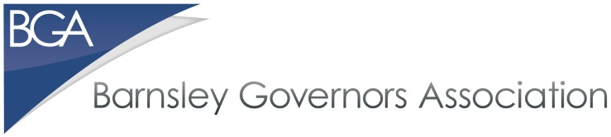

REQUEST TO JOIN THE BGA

The subscription registers all the governors of your school as members of the Barnsley Governors Association (BGA), for year dated April 2018-2019. This means that training courses will cost only £30 per person per session rather than £50 for non-members. There are also discounts for multiple attendees from the same school on the same course. The cost for two or three attendees is £40 and £45 respectively.

MATs and SATs are also able to become members, which will then allow their staff to attend training courses, such as Safeguarding and Safer Recruitment, at the lower members’ rate(s).

The fee for the year is £50.00 per governing body/local governing body/MAT/SAT.

NOTE: Individual governor membership subscription of £10 per year is also available.

Please complete your details as below and send this form to treasurer@barnsleyga.org. On receipt, the treasurer will send by return details of how to make payment.

School/MAT/SAT: ...............................................................................................................

Contact Name: ..................................................................................................................

Contact Email Address: …………………………………………………………………………

Thank you,

Margaret Gostelow, Treasurer

